Project Design Phase

Problem – Solution Fit Template

Date | 20 February 2026
Team ID | LTVIP2026TMIDS70508
Project Name | Learn Hub : Your Center for Skill Enhancement
Maximum Marks | 2 Marks

Problem – Solution Fit Template:
The Problem-Solution Fit simply means that we have identified a real problem faced by our target customers and developed a solution that effectively addresses it. It helps in understanding customer behavior, identifying constraints, and designing a solution that aligns with their needs and expectations.

Purpose:
- Solve learning accessibility and affordability problems effectively.
- Increase adoption of online learning through structured course design.
- Improve communication and engagement using progress tracking and certificates.
- Build trust by providing secure authentication and verified completion certificates.
- Understand the learning challenges faced by students and improve their experience.

Template:
1. Customer Segment(s): Students, working professionals, and learners seeking affordable online education.
2. Jobs-To-Be-Done / Problems: Access quality education remotely, track learning progress, and obtain certification.
3. Triggers: Need for skill development, job requirements, exam preparation, career growth.
4. Emotions (Before / After): Before – Confused, frustrated, financially stressed. After – Confident, satisfied, motivated.
5. Available Solutions: Traditional classroom learning, YouTube tutorials, expensive online platforms.
6. Customer Constraints: Budget limitations, internet connectivity issues, limited time availability.
7. Behaviour: Search online courses, compare platforms, watch demo videos before enrolling.
8. Channels of Behaviour: Online – Social media, search engines, learning platforms. Offline – College recommendations, peer suggestions.
9. Problem Root Cause: High cost of traditional education and lack of structured progress tracking.
10. Your Solution: Learn Hub provides structured courses, progress tracking, certificate generation, and secure authentication using MERN stack.

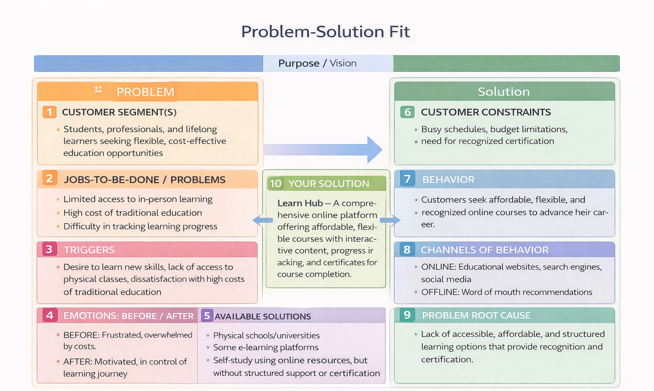

References:
1. https://www.ideahackers.network/problem-solution-fit-canvas/
2. https://medium.com/@epicantus/problem-solution-fit-canvas-aa3dd59cb4fe

